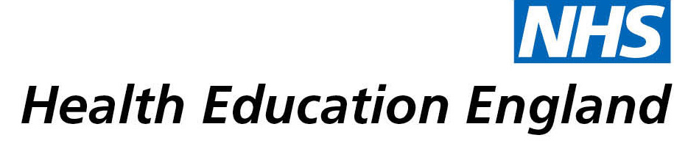

# Library and Knowledge Services case study

# *Nottinghamshire Healthcare NHS Foundation Trust: COVID19 wellbeing survey and publications*

28th April 2021

## Reason for enquiry

Consultant was working on a survey entitled "Experience of UK frontline health staff of working in the COVID19 pandemic – impact on wellbeing and possible remedies". The request was for literature searches on:

* "Psychological impact of epidemics/pandemics on the population"
* "Impact of epidemics/pandemics on the wellbeing of health workers/staff"

## What the knowledge and library specialist did

The searches were kept separate so that the results could focus on the two different populations. The search was run in April 2020 so the literature base was limited for COVID19 articles at the time (or were limited to rapid reviews or editorials) so the strategy incorporated past pandemics in a broad sense so they could draw conclusions from past experiences and focus and translate it for COVID19.

Quote: "*All these projects wouldn’t have been possible to materialise without the crucial and instrumental input and support of the Library and Knowledge Services. I am really grateful for the availability of this service of paramount importance to ensure an evidence-based practice to improve the lives of our patients, the population, and the staff. And I’m grateful for the ongoing support from you and all the staff in the Library Service to achieve this goal continuously improve the evidence base informing the clinical practice within the Trust and beyond*."

# Impact of input from the library and knowledge service

The search helped to complete a survey undertaken with the frontline NHS workers across the country about their experience of working in the health sector during the peak of the first wave of the pandemic. This project has achieved two publications, one in International Journal of Social Psychiatry and the other is accepted in British Journal of Healthcare Management.

## Immediate Impact

**Improved the quality of patient care**

**More informed decision making**

**Contributed to service development or delivery**

**Contributed to personal or professional developments**

The response was overwhelming. This explored the impact on emotional wellbeing and mental health of NHS workers, their coping strategies and what the NHS Trusts leaders and other employers should do to mitigate that and optimise support to the frontline NHS staff.

## Probable future Impact

**Improved the quality of patient care**

**More informed decision making**

The results go towards helping to reduce the impact of the pandemic on the wellbeing and mental health of NHS staff during the pandemic.

## Submission by:

Pallab Majumder, Consultant Child and Adolescent Psychiatrist

## For further information on how you can get similar support contact your local NHS library and knowledge service.